

National Textile University
Department of Computer Science
Subject: Mobile Application Development

Submitted to: Sir Rehan

Submitted by: Ayema

Reg. number: 23-NTU-CS-1142

Lab:4

Semester:6th

Phase 1
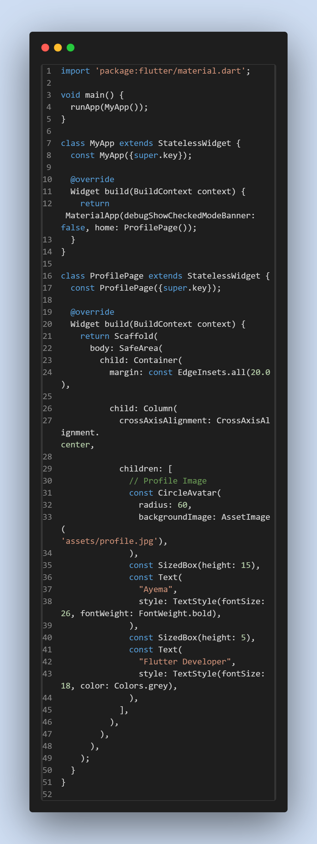5

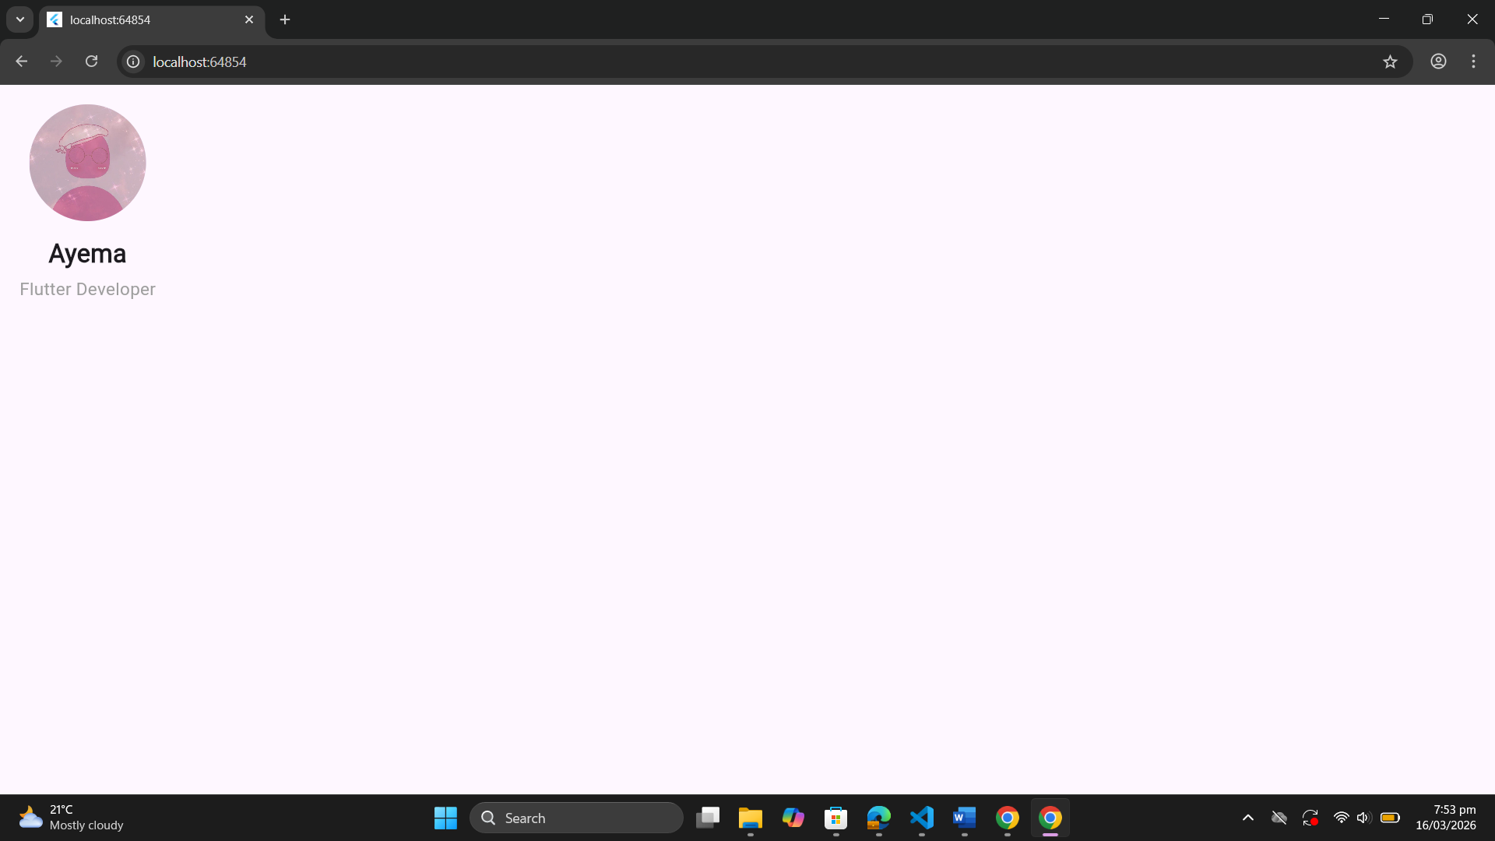

Phase 2
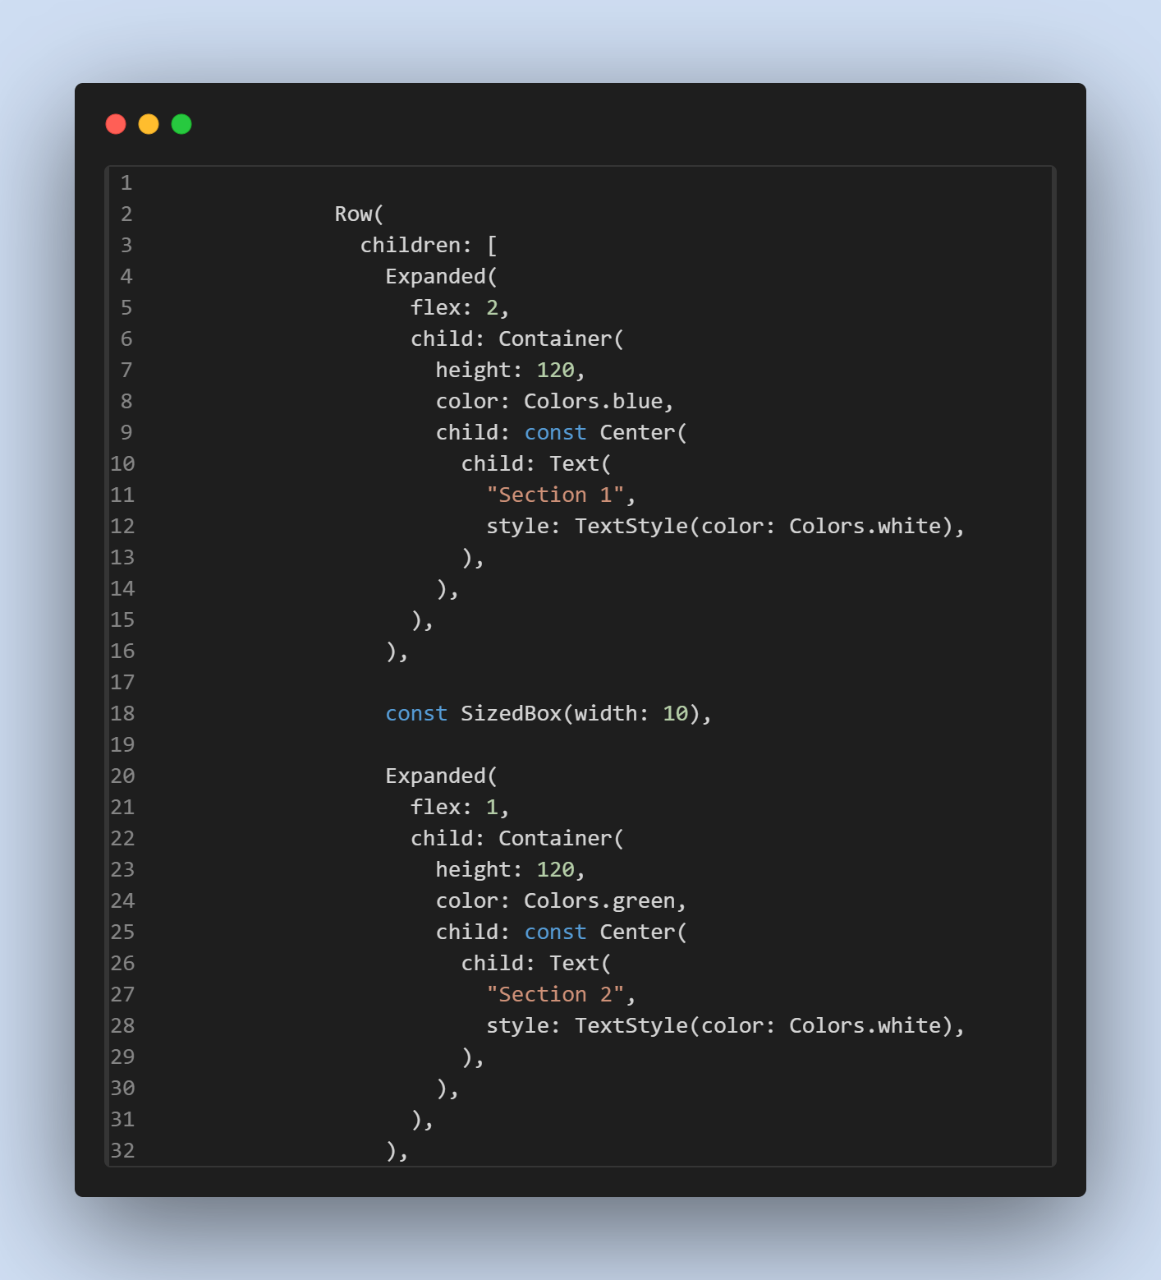
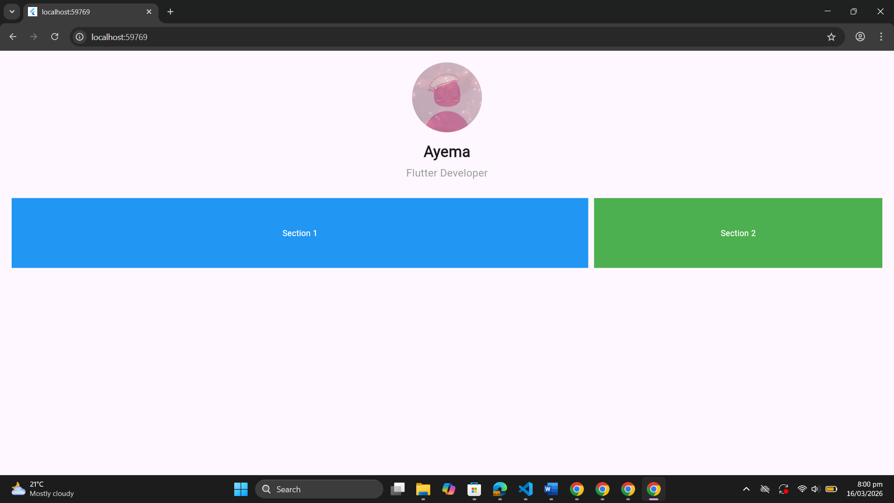

Phase 3
